Data Structures – Project Report 1

Assigned: May 17, 2019
Due Date: May 29, 2019

Team Group J

Please write the names of everyone who worked on this assignment.

Name 마신욱 MA XINYU Student ID 2017057138

Name 이초림 LI ZUOLIN Student ID 2017057147

Name 장호우 ZHANG HAOYU Student ID 2018000337

Name 탄자오종 TAN ZHAOZHONG Student ID 2018057683

Name 장양철우 ZHANG LIANGZHEYU Student ID 2018057674

Name Student ID

This assignment should be completed together with your team. Each team should do this only once. Please print this and bring it to class.

- Please write down the amount of time needed to run each program for the indicated values of n:

Value of n | 10 | 20 | 30 | 40 | 42 | 44 | 46 | 48 | 50
Fibonacci1 | 0.00000180 | 0.00007670 | 0.00535700 | 0.68075478 | 1.63515091 | 4.63861227 | 10.89761257 | 30.92007637 | 74.38647461

Value of n | 100000000 | 200000000 | 300000000 | 400000000 | 500000000
Fibonacci2 | 0.30162829 | 0.60176861 | 0.90343791 | 1.20200253 | 1.49874616
Fibonacci3 | 0.37110710 | 0.74505562 | 1.05776322 | 1.49083698 | 1.81578958
Fibonacci4 | 0.00000060 | 0.00000080 | 0.00000060 | 0.00000070 | 0.00000080

- Use the above timings to derive a formula for the amount of time each program requires

Fibonacci1 | T(n) = xyn | x =6×10^-9 | y =1.59 | T(n) = Θ( 2^n )
Fibonacci2 | T(n) = xny | x =3×10^-9 | y =1 | T(n) = Θ( n )
Fibonacci3 | T(n) = 3.6×10^-9 n |  |  | T(n) = Θ( n )
Fibonacci4 | T(n) = 7×10^-7 |  |  | T(n) = Θ( 1 )

- Plot a graph of the running time of Fibonacci1.c:
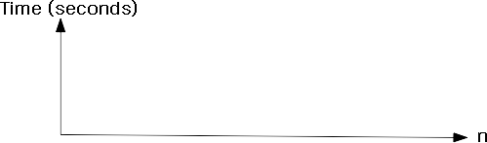

- Plot a graph of the running time of Fibonacci2.c:
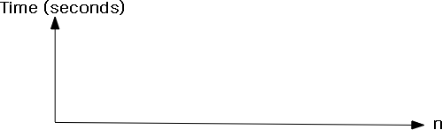

- Plot a graph of the running time of Fibonacci3.c:

- Plot a graph of the running time of Fibonacci4.c:

